

TAMILNADU SKILL DEVELOPMENT CORPORATION
Naan Mudhalvan Niral Thiruvizha Declaration Form
- Name of the College: ST.JOSEPH'S COLLEGE OF ENGINEERING

- College code: 3123
- Theme: Agriculture/ Food Tech
- Problem statement: How might we develop a solution to reduce pesticide and fertilizer usage by integrating Soil Health Card data, weather data, and the Leaf Color Chart method? This app should provide farmers with precise, location-specific recommendations to optimize input usage, enhance crop health, and promote sustainable agricultural practices.

- Faculty Guide Details:
Dr. Ancy S,Associate Professor ,AML department,
St.Joseph’s College Of Engineering ,9445110200, dicksonancy@gmail.com

Team Leader Name | Reg.No | Year | Department | Mobile No
FELIX KEVINSINGH T | 21AM205 | IV | AML | 9499949330
Team members
JAMES ROBIN RAJ P | 21AM107 | IV | AML | 9360581431
LAKSHMISIMHA REDDY KASIREDDY | 21AM136 | IV | AML | 7382093115
KEVIN JEYARAJ | 21AM114 | IV | AML | 9994473214

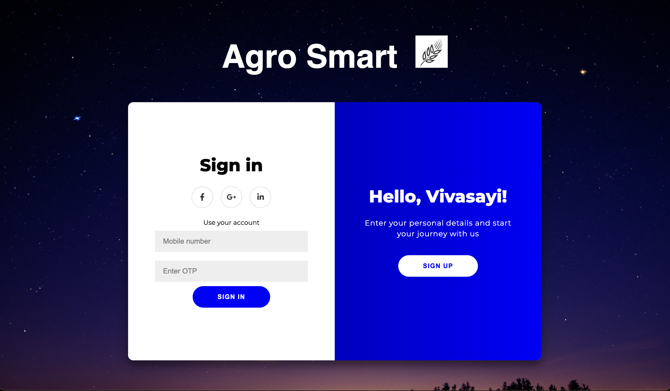
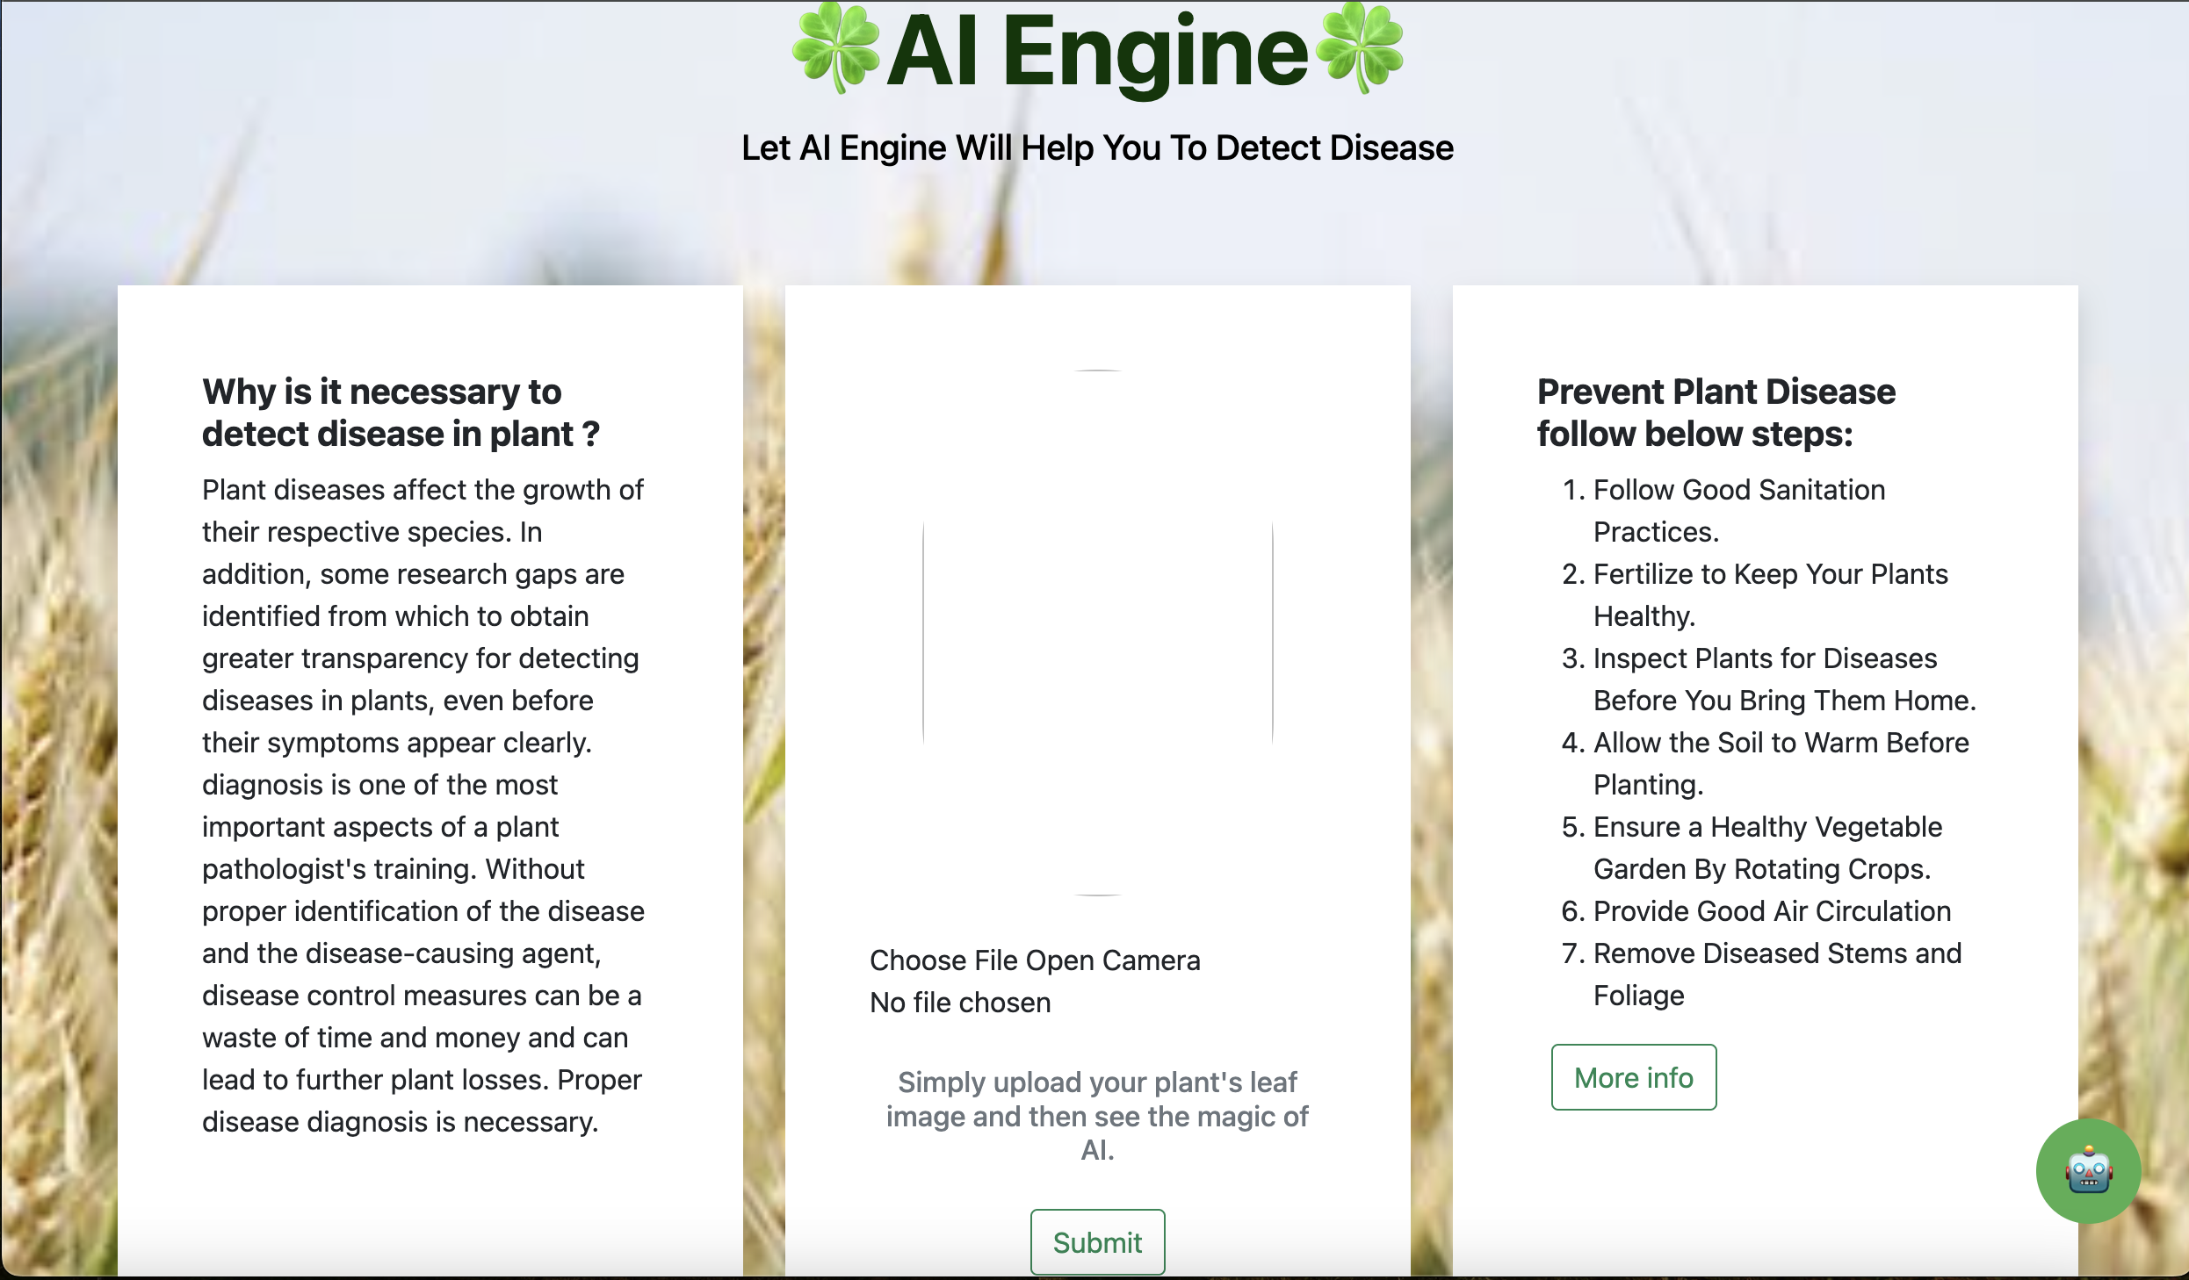
- Attach photos of the prototype/App/Software:

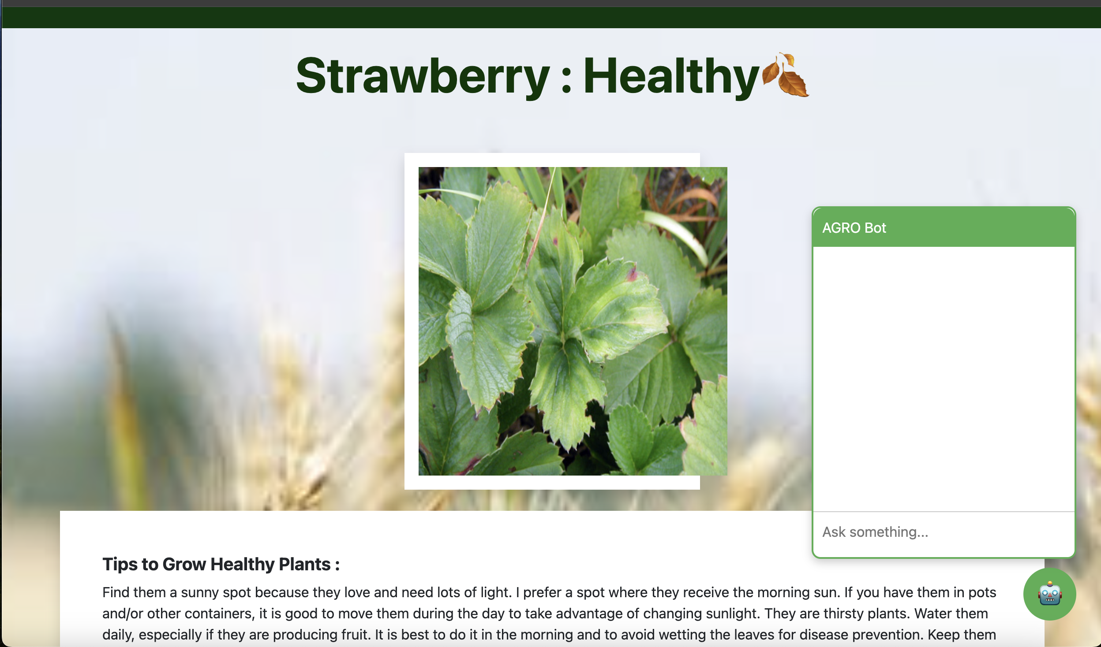
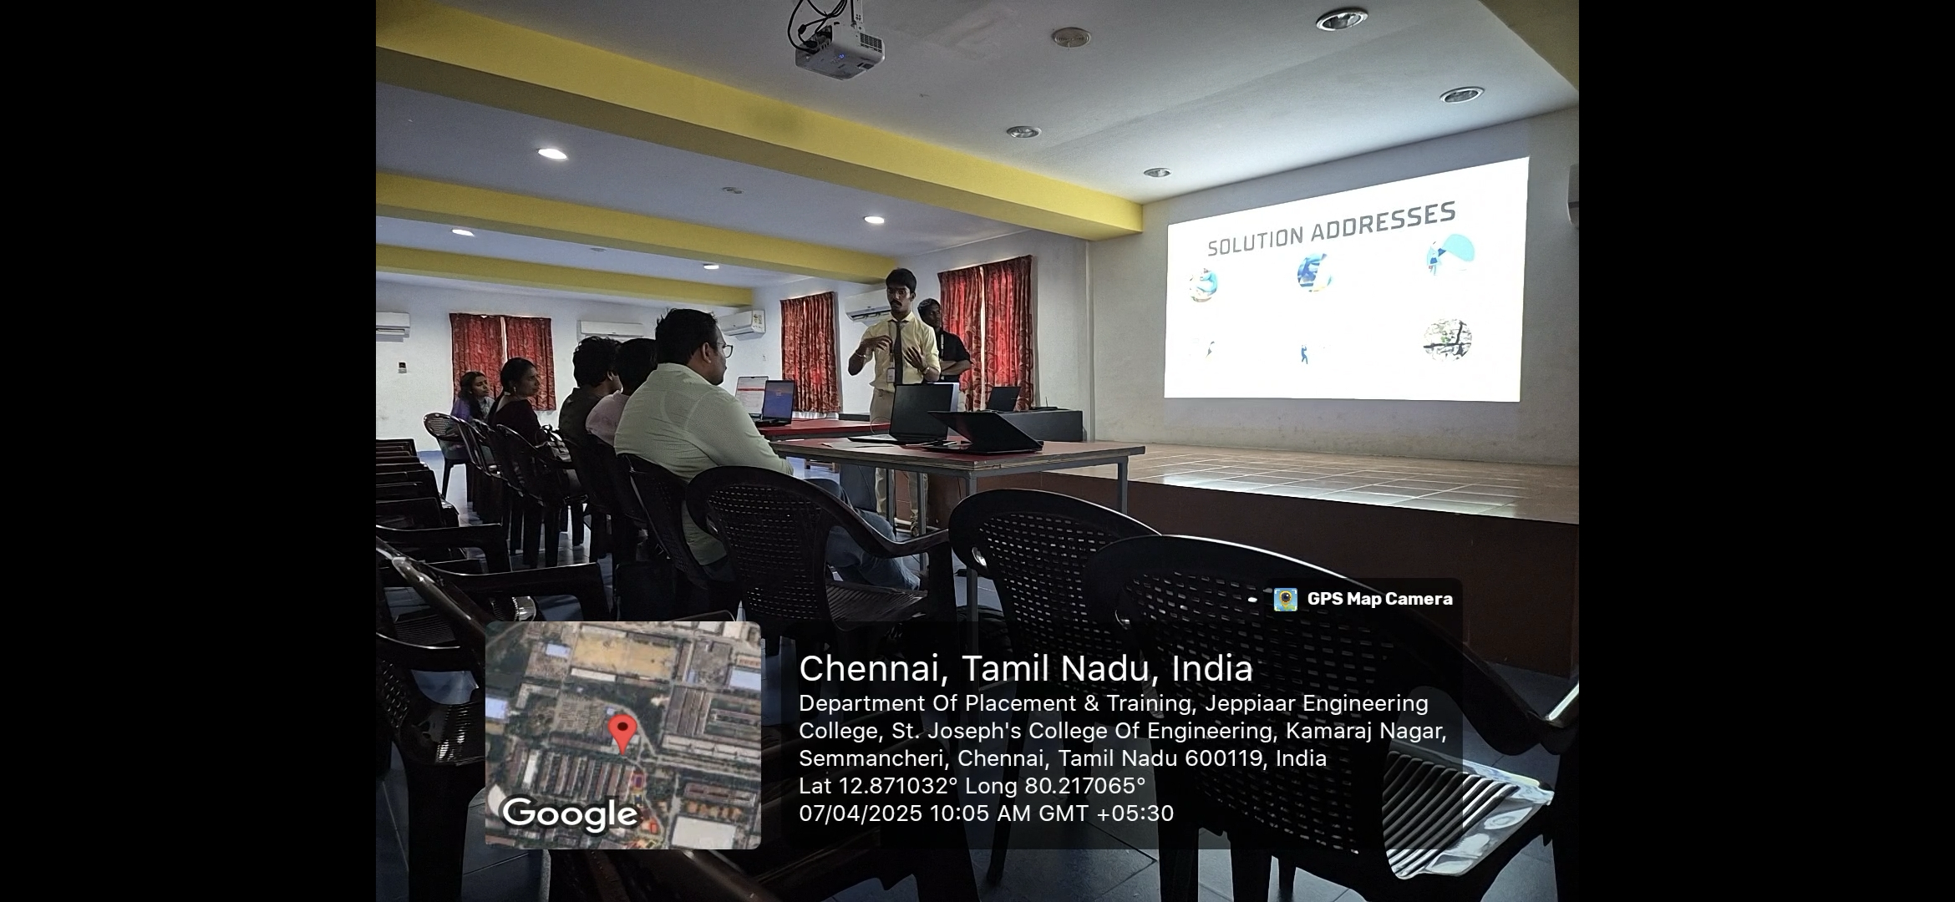
- Attach photos of the 2nd Review:

UNDERTAKING

- The college will provide the basic infrastructure and other required facilities to the students for timely completion of their projects.
- The college will undertake the financial and other management responsibilities of the project also; college will be responsible in following the time lines.
- The college will ensure that the funds provided are utilized only for the purpose provided and any remaining amount will be returned back to the University after the time of completion of the project.
- I hereby declare that the details furnished above are true and correct.

Signature of Faculty Guide Signature of Principal

